22) Aim: To Design Deterministic Finite Automata using simulator to accept odd number of a’s.

Diagram:

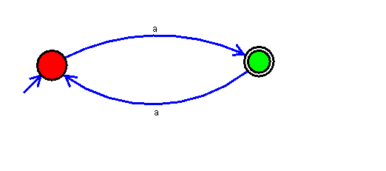

Result:

Successfully executed Deterministic Finite Automata using simulator to accept odd number of a’s.